A000-Afr-Burkina Faso-Mossi Yatenga Mask-20th c

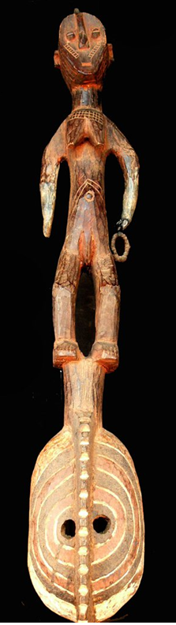 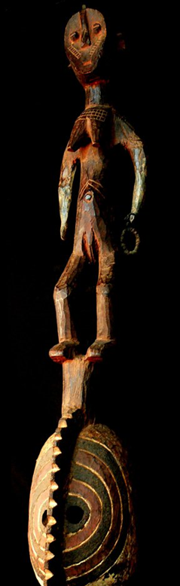 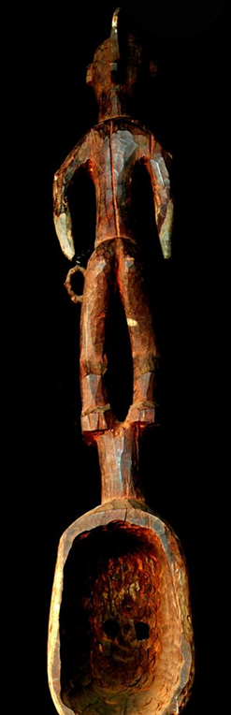

Figs. 1-3. Afr-Burkina Faso-Mossi Yatenga Mask-20th c

Case No.: 6

**Accession No.**

**Formal Label:** . Afr-Burkina Faso-Mossi Yatenga Mask-20th c

**Display Description:**

**LC Classification:**

**Date or Time Horizon:**

**Geographical Area:**

**Map:**

**GPS coordinates:**

**Cultural Affiliation:**

**Media:**

**Dimensions: H** 44 inches

**Weight:** 2.91 pounds

**Condition:**

**Provenance:**

**Discussion:**

**References:**